CSA1717-ARTIFICIAL INTELLIGENCE
PRACTICAL LAB EXPERIMENTS
NIHARIKA PREEJESH (192524506)

PROGRAM 11: TRAVELLING SALESMAN
Aim: To implement the Travelling Salesman Problem (TSP) to find the shortest possible route that visits each city exactly once and returns to the starting city.
Algorithm:
- Define the cities and the distances between them.
- Select a starting city.
- Generate all possible routes.
- Calculate the total distance of each route.
- Compare the distances of all routes.
- Select the route with the minimum total distance.
- Display the shortest route and its total distance.

Flowchart:
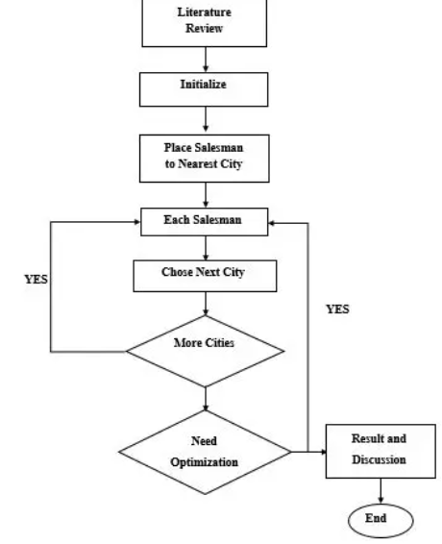
Output:
Shortest Route:
A → B → D → C → A

Minimum Distance = 80
Result:
Thus, the Travelling Salesman Problem (TSP) was implemented successfully, and the shortest possible route covering all cities was obtained.

